**Environmental Assignment**

**Sophie-Diane Donker**

**Christiaan Kingsale**

**Sheelah Arends**

**Natalia Loaiza Marin**

**Arduino Sensor: Soil moisture – Conductivity**

1. Parameter and what is indicated when the parameter increases or decreases
2. Standard values
3. Values at University of Aruba
4. What are we measuring?
5. Pictures
6. How the sensor works
7. Code
8. **Parameter and what is indicated when the parameter increases or decreases**

The sensor we have chosen which is the Soil moisture - Conductivity sensor, provides us with data that is not specified in any unit. This means that the data seen on the screen, for example ‘sensor=77’ ,has no specific unit. However, the data provided by the sensor can be transformed into a specific unit like Volt using specific calculations. The parameter can either increase or decrease. An increase of the parameter indicates that the soil moisture is increasing, leading to higher conductivity in the soil. If the parameter indicated by the sensor decreases means that the soil moisture is low or the soil might even be dry, leading to low or no conductivity in the soil.

**2. Standard values**

When measuring soil moisture it is possible to divide the measurements in a way that indicates how moist the soil is. We divided this scale into three different categories. In the three categories of soil moisture we have three different types of soil. The usual measurements of soil run from 0 up to 950. However, our sensor has an error and that makes it run up to 1023. By using some calculations we have created our own scale, based on standard values to determine the moisture of the soil. The standard value of the soil is normally as follows: 0- 300 is dry soil

300-700 is humid soil

700-950 is sensor in water

However, since our sensor has an error and runs up to 1023 we used the usual values and created our own scale:

* (300/950) x 100% = 31.58% => 31.58% x 1023 = 324
* (700/950) x 100% = 73.68% => 73.68% x 1023 = 754

Using these calculated values we created the table below:

|  |  |
| --- | --- |
| Sensor in dry soil | 0 - 324 |
| Sensor in humid soil | 324 - 754 |
| Sensor in water | 754 - 1023 |

Aruba is an island located very close to the equator. Due to its location is has sunshine all year round with slight rainfall throughout the year. This most soil around the island enough time to dry up. Due to Aruba’s climate, the soil in most parts of Aruba is mostly dry because the soil is exposed to sunshine year round. According to Koppen Climate Classification Aruba has a climate similar to a warm desert climate(BWh) and a warm semi-arid climate(BSh). From this information we can conclude that the majority of the Aruban soil is made out of Alfisols which is a types of soil which forms in semi-arid and humid areas. Alfisols form in semi-arid areas but may contain a high amount of nutrients which may drive the conductivity upwards.

**3. Values at University of Aruba**

During class we went outside in the University of Aruba garden to measure the moisture of the soil in the garden. We measured the soil moisture in different places. The University of Aruba garden has many different plants, some which are constantly exposed to the sun and others that are partly in the sun and in the shade. We measured four different places where the soil is exposed to the sun most of the day. These were the results of those places. From these measurements we can conclude that soil which is exposed to the sun is probably dry.

|  |  |
| --- | --- |
| Soil #1 | sensor = 34 |
| Soil #2 | sensor = 27 |
| Soil #3 | sensor = 8 |
| Soil #4 | sensor = 91 |
| Soil #5 | sensor = 68 |
| Soil #6 | sensor = 12 |

We also measured soils which were exposed to the sun as well as in the shade throughout the day. These measurements showed that the even the soils in the shade that would be considered humid had low soil moisture and were leaning more on the dryer side.

|  |  |
| --- | --- |
| Soil #7 | sensor = 331 |
| Soil #8 | sensor = 318 |

However, one of our measurements indicated that the soil was around 856 in an area where the soil was in the shade. We can then conclude that the soil there was humid because it is not in water but it that it may also contain salts and minerals that drive the conductivity upwards. We also inserted the sensor in a water bottle. This water was tap water. In this water, the soil moisture at first was 745 and afterwards after 20 seconds the sensor ran the data again and the soil moisture raised up to 824.

**4. What are we measuring?**

The sensor we have is used to measure soil conductivity. Conductivity is a measure of water’s capability to pass electrical flow. Conductivity is determined by the moisture of the soil. The higher the moisture(indicated by the sensor), the higher the conductivity. There are different reasons as to why people measure soil conductivity and there is a lot of information that can be concluded from soil conductivity measurements, which is why it is very important to collect data about soil moisture. Some examples are:

* Soil conductivity is important for farmers that participate in agricultural activities. The higher the level of soil conductivity indicates the amount of nutrients available for their crops to absorb.
* Soil conductivity can indicate potential consequences for the water cycle, such as contamination of the groundwater we as humans consume. Geologic layers that contain water are known as aquifirs. Areas where surface water filters into an aquifir are recharge zones. Contaminants can also enter aquifirs through recharge zones which leads to contamination of the groundwater. These contaminants often include urban or agricultural run-offs filled with nutrients and chemicals. These nutrients and chemicals drive soil conductivity upwards. So measuring the soil moisture may indicate whether or not the soil is contaminated.

5. Pictures:

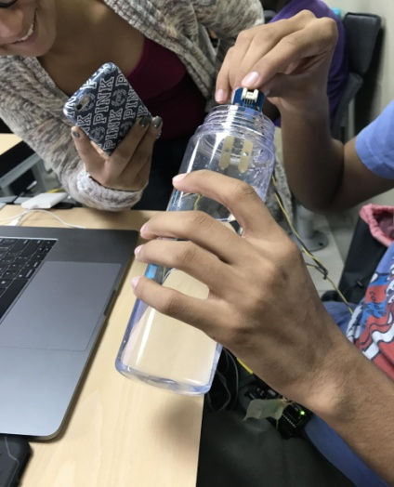 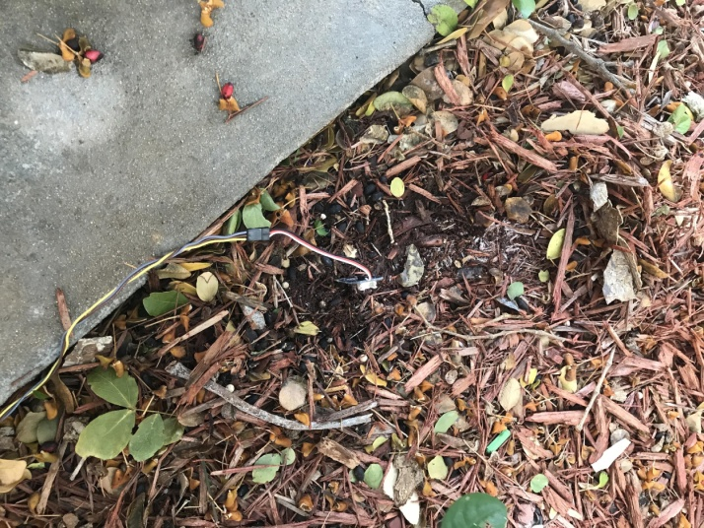

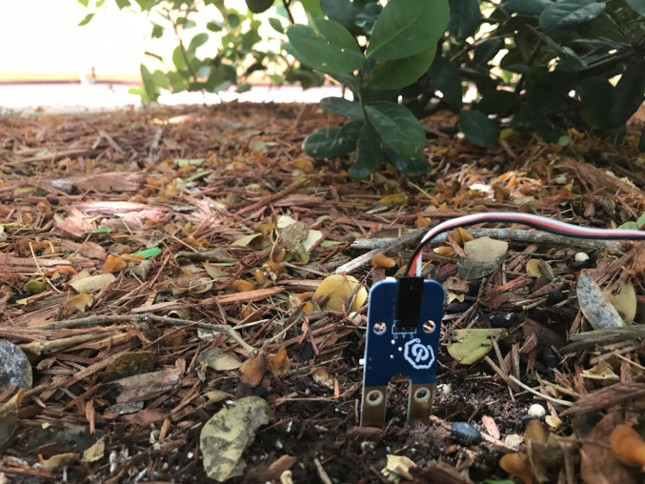 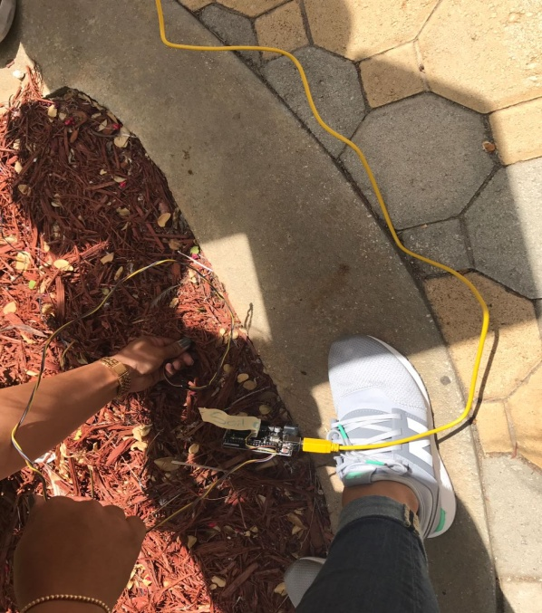

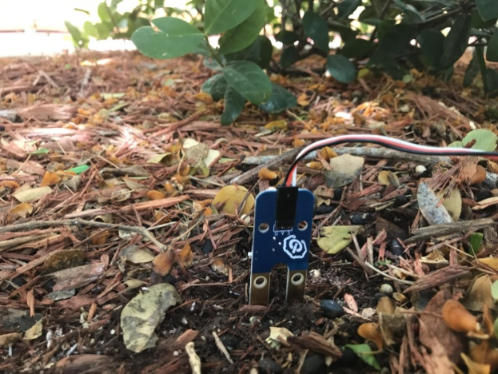 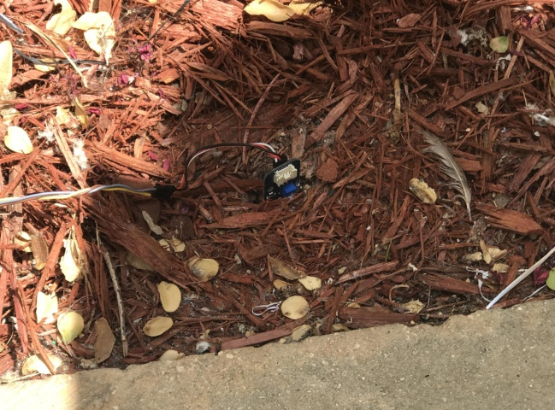

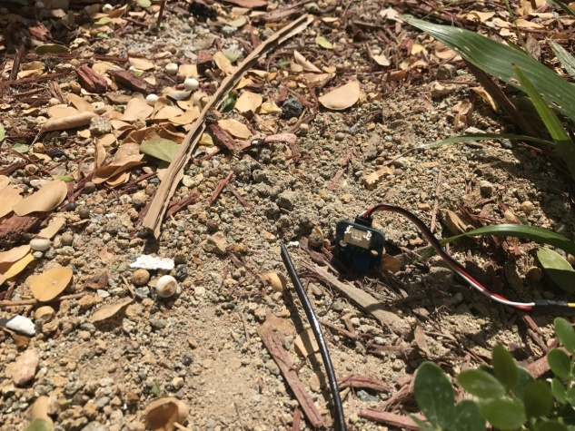 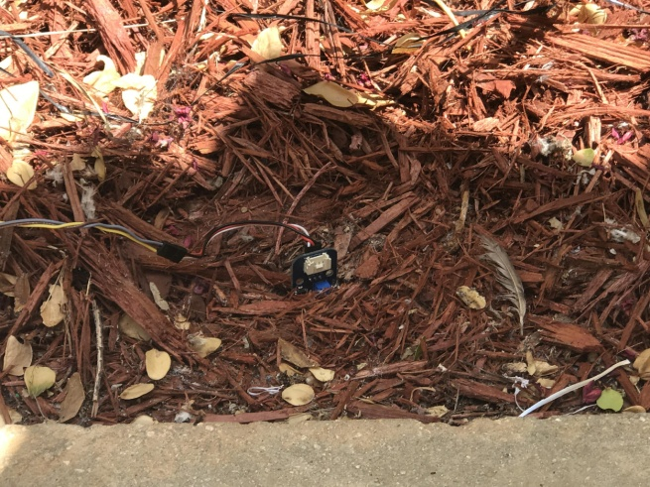

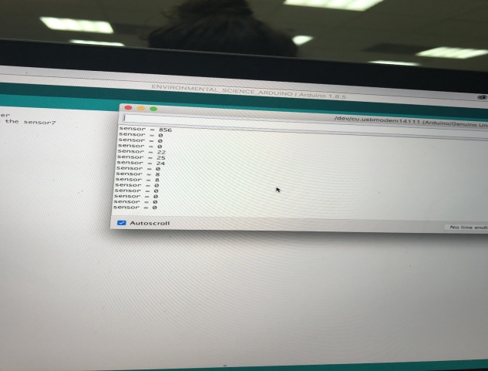 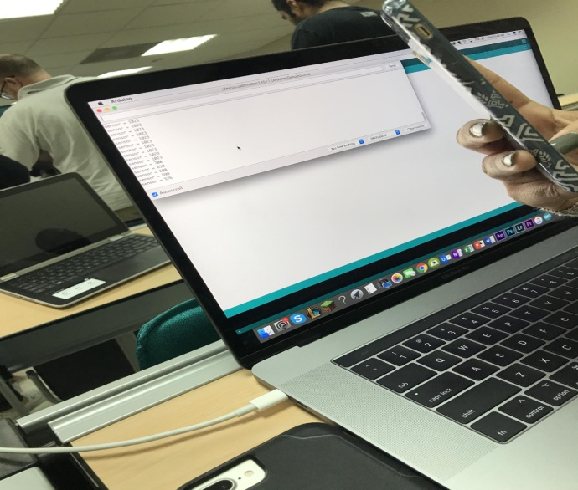

**6. How does the sensor work?**

As mentioned before, the sensor measures conductivity by measuring the soil moisture. The sensor has two pads which work as variable resistor. The sensor measures the water present in the soil depending on the conductivity between the two pads. More water means more/faster transportation of electricity from one pole/pad to the other on the sensor. The higher the number indicated by the sensor, the higher the soil moisture meaning higher conductivity. The lower the number, the lower the soil moisture meaning less conductivity. The data is later on delivered to the device to which the sensor is connected. The sensor runs the data multiple times. The time in which the sensor runs the data is determined by the time interval we set on the sensor. In this case we have set a delay of 20 seconds because it takes time for the sensor to measure the moisture of the soil. This is due to the fact that the water molecules have to make their way to the sensor in order for it to be able to indicate the moisture of the soil. The data gathered can later on be transformed into a specified unit such as volts using specific calculations and the data from the sensor. We can use the standard value to determine the conditions of the ground and if they are adequate (for example for agriculture).

**7. Code**

// Test code for Grove - Moisture Sensor

int sensorPin = A0; // select the input pin for the potentiometer

int sensorValue = 0; // variable to store the value coming from the sensor7

void setup() {

  // declare the ledPin as an OUTPUT:

  Serial.begin(9600);

}

unsigned long timeout = 20000;

unsigned long ofset = 1000;

void loop() {

    // read the value from the sensor:

  sensorValue = abs(analogRead(sensorPin) - 1023);

    sensorValue = map(sensorValue, 0, 525, 0, 700);

  Serial.print("sensor = " );

Serial.println(sensorValue);

  delay(timeout);

}